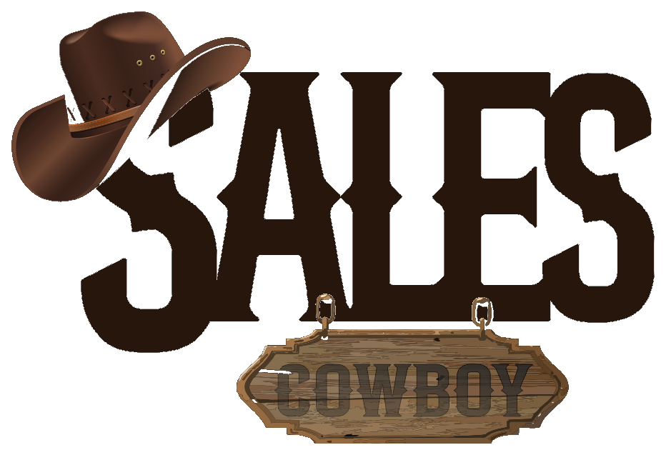 SALES COWBOY  Marketing Solutions • Hospitality Revenue Engineering  36, Arochukwu Street, Uratta East, Owerri North, Imo, Nigeria  hello@salescowboy.com.ng • +234 810 493 3232 • salescowboy.com.ng | PRE-OPENING MASTER CHECKLIST  REF: CHK-MBAISE-2026-001  DATE: November 06, 2026  STATUS: ADVISORY
――――――――――――――――――――――――――――――――――――――――――――――――――――――――――――
NEW HOTEL PRE-LAUNCH & DIGITAL REVENUE MASTER CHECKLIST
Operational, Local Search Dominance & Zero-OTA Commission Architecture for a Clean-Slate Launch
TARGET PROPERTY:  New Hotel & Suites (Pre-Opening)  Location: Oru, Ahiara Mbaise, Imo State, Nigeria  Corridor: Owerri-Umuahia Expressway / Ahiara Junction Axis | PREPARED BY (CONSULTING GROUP):  Sales Cowboy Marketing Solutions (Owerri Office)  36, Arochukwu Street, Uratta East, Owerri North, Imo, Nigeria  Contact: +234 810 493 3232 • hello@salescowboy.com.ng
THE 'CLEAN SLATE' ADVANTAGE IN MBAISE
Opening a brand-new hotel in Oru, Ahiara Mbaise means you have zero legacy errors, bad reviews, or broken software to fix. Mbaise is one of Nigeria's wealthiest diaspora corridors with massive seasonal influxes (Iri Ji Mbaise in August, festive weddings in December, Easter, burials). By launching with this checklist, your hotel will capture 100% direct guest payments with 0% OTA commission loss, automated 24/7 WhatsApp room sales, and Day-1 5-star Google review authority.
PHASE 1: BRAND IDENTITY, NAMING & STATUTORY FOUNDATION (T-minus 60 Days)
[ ] Brand Naming & Domain Check: Verify name uniqueness and register .com / .com.ng domain.
[ ] CAC Corporate Registration: Register entity with Corporate Affairs Commission for banking and tax compliance.
[ ] Corporate Visual Identity: High-res logo suite, brand typography, signboards, staff uniform badges, and linen embroidery.
[ ] Commercial Banking (NUBAN): Open dedicated corporate accounts with Paystack merchant settlement profiles.

PHASE 2: GOOGLE MAPS & LOCAL SEARCH DOMINANCE (T-minus 45 Days)
[ ] Google Business Profile (GBP) Creation: Drop exact GPS pin in Oru, Ahiara Mbaise along expressway approach.
[ ] Address Verification: Complete video/postcard verification before grand opening to ensure Day-1 search ranking.
[ ] Core Amenities Tagging: Standby 24/7 Generator, AC Suites, Gated Security, Restaurant, Bar, Complimentary Breakfast.
[ ] Geo-Tagged Photography: Upload 25+ high-res architectural photos tagged to Ahiara Mbaise coordinates.

PHASE 3: DIRECT BOOKING WEBSITE & ZERO-COMMISSION ENGINE (T-minus 30 Days)
[ ] Mobile-First Direct Booking Site: High-speed 5-8 page website showcasing room types, suite tariffs, and event halls.
[ ] Paystack / Monnify Checkout: Direct online card, USSD, and bank transfer checkout landing 100% in your corporate account.
[ ] Eliminate 20% OTA Commission: Prevent ₦3,000 to ₦6,000 commission losses per room night to Hotels.ng & Booking.com.
[ ] Google Analytics 4 & Search Console: Setup tracking for visitor traffic from Lagos, Abuja, Owerri, and diaspora.

PHASE 4: 24/7 AUTONOMOUS WHATSAPP AI CONCIERGE BOT (T-minus 25 Days)
[ ] Official WhatsApp Business API: Connect dedicated hotel line with sub-15 second automated response speed.
[ ] Autonomous Room Sales: Bot sends room photos, live tariffs, bar/kitchen menus, and check-in policies inside WhatsApp.
[ ] Instant Payment Link Dispatch: Dispatches Paystack payment links in chat and issues instant booking vouchers.
[ ] Late-Night Arrival Notification: Automatically alerts front-desk staff when midnight travelers are en route.

PHASE 5: CLOUD PROPERTY MANAGEMENT SYSTEM (PMS) & MULTI-POS (T-minus 20 Days)
[ ] Visual Room Rack Calendar: Interactive cloud availability grid (Available, Occupied, Dirty, Maintenance).
[ ] Multi-Outlet POS Billing: Direct bar and restaurant drink/meal billing charged to guest room folio.
[ ] Multi-Channel OTA Sync: 2-way sync with Booking.com and Airbnb so direct bookings automatically block OTA calendars.
[ ] Daily Cashier Night Audit: Automated daily revenue reports reconciling cash, POS machines, and online transfers.

PHASE 6: FRONT-DESK REVIEW ACCELERATION SYSTEM (T-minus 15 Days)
[ ] Acrylic NFC + QR Review Stands: Custom heavy-duty branded review stands on reception desk, bar, and executive suites.
[ ] Smart 2-Way Review Gateway: Routes 5-star guests directly to Google Maps; diverts critical feedback privately to GM.
[ ] Automated Post-Checkout Follow-Up: WhatsApp thank-you message delivered 2 hours after checkout with review link.
[ ] Staff Incentive Matrix: ₦500 bonus for receptionists for every verified 5-star review mentioning their service.

PHASE 7: PHYSICAL WAYFINDING & TRANSIT SIGNAGE (T-minus 15 Days)
[ ] Ahiara Junction Approach Billboard: Clear directional signage at the major junction indicating distance and turnoff.
[ ] Oru Feeder Road Directional Signage: Reflective markers along the access road eliminating traveler confusion.
[ ] Perimeter Gate Illuminated Signage: Floodlit / backlit exterior corporate gate sign visible to night motorists.

PHASE 8: LAUNCH MARKETING & DIASPORA/WEDDING CAMPAIGN (T-minus 10 Days)
[ ] 4K Facility Video Shoot: Professional video reels highlighting suites, bar ambiance, and chef delicacies.
[ ] Event Planner Database Outreach: Connect with wedding planners and church diocesan coordinators across Mbaise.
[ ] Targeted Meta Ad Blitz: Run Facebook/Instagram ads targeting Mbaise indigenes in Lagos, Abuja, PH, and abroad.

SALES COWBOY TURNKEY DEPLOYMENT PACKAGES
COMPONENT | DELIVERABLES | TIMELINE
1. Direct Booking Website | 5-8 Custom Pages, Room Catalog, Paystack/Monnify Checkout, Domain & 1 Yr Cloud Hosting | 7 Days
2. 24/7 WhatsApp AI Bot | Official WhatsApp API, Automated Room Photos, Rates, Payment Links & Vouchers | 7 Days
3. Google Business Profile | Complete GBP Setup, Map Pin Drop, Verification & Geo-Tagged Photo Curation | 5 Days
4. Smart Review QR Stands | 2x Custom Acrylic Front-Desk Stands (NFC + Dynamic QR) & Negative Review Gatekeeper | 5 Days
5. Cloud Hotel PMS Software | Room Rack Calendar, Front-Desk Check-In/Out, Bar/Restaurant POS & Multi-Channel Sync | 14 Days

SALES COWBOY MARKETING SOLUTIONS
Hospitality Revenue Engineering & Systems Group
36, Arochukwu Street, Uratta East, Owerri North, Imo, Nigeria
Direct Line: +234 810 493 3232 • Email: hello@salescowboy.com.ng • salescowboy.com.ng

